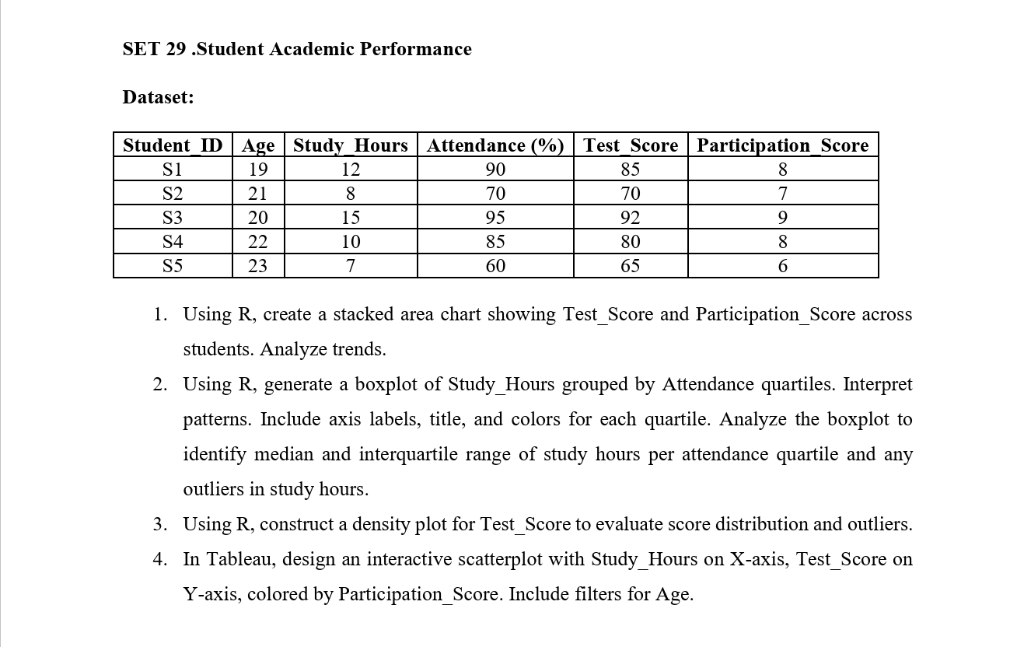

SET 29 – Student Academic Performance

Question 1: Stacked Area Chart of Test Score and Participation Score

Aim
To create a stacked area chart in R showing Test Score and Participation Score across students and analyze the trends in academic performance and participation.

Code
Question 1 – Stacked Area Chart
# Create Dataset
student <- data.frame(
Student_ID = c("S1", "S2", "S3", "S4", "S5"),
Age = c(19, 21, 20, 22, 23),
Study_Hours = c(12, 8, 15, 10, 7),
Attendance = c(90, 70, 95, 85, 60),
Test_Score = c(85, 70, 92, 80, 65),
Participation_Score = c(8, 7, 9, 8, 6)
)

# Stacked Area Chart
scores <- rbind(
student$Test_Score,
student$Participation_Score
)

scores <- t(scores)

colnames(scores) <- c("Test Score", "Participation Score")

rownames(scores) <- student$Student_ID

# Plot
matplot(1:5, scores,
type = "n",
xlab = "Students",
ylab = "Scores",
main = "Student Test and Participation Scores",
xaxt = "n")

axis(1, at = 1:5, labels = student$Student_ID)

polygon(c(1:5, 5:1),
c(scores[,1], rep(0, 5)),
col = "skyblue",
border = "blue")

polygon(c(1:5, 5:1),
c(scores[,1] + scores[,2],
rev(scores[,1])),
col = "orange",
border = "red")

legend("topleft",
legend = c("Test Score", "Participation Score"),
fill = c("skyblue", "orange"))

Output:
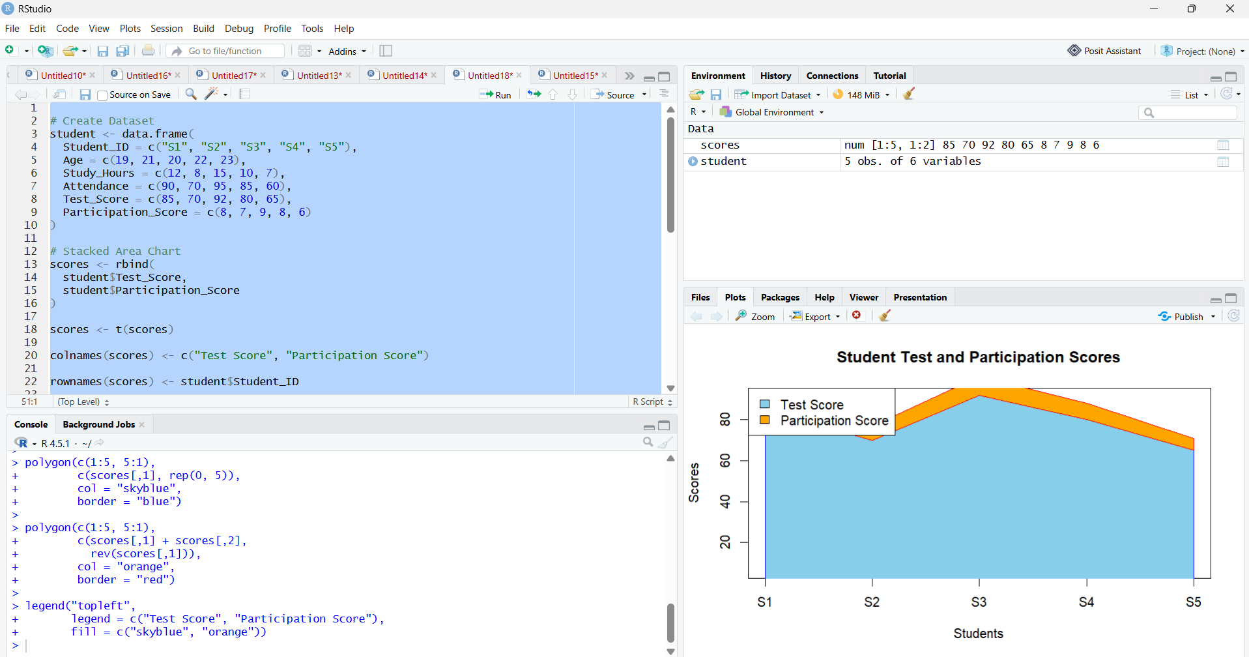

Result
The stacked area chart represents the test and participation scores of five students. Student S3 achieves the highest test score of 92 and participation score of 9. Student S5 has the lowest test score of 65 and participation score of 6. The chart suggests that higher participation scores are associated with better test scores in this small dataset. However, participation scores are measured on a different scale from test scores, so the stacked areas should be interpreted cautiously.

Question 2: Boxplot of Study Hours Grouped by Attendance Quartiles

Aim
To create a boxplot of study hours grouped by attendance quartiles and identify the median, interquartile range, and potential outliers for each group.

Code
Question 2 – Boxplot
# Create Dataset
student <- data.frame(
Student_ID = c("S1", "S2", "S3", "S4", "S5"),
Study_Hours = c(12, 8, 15, 10, 7),
Attendance = c(90, 70, 95, 85, 60)
)

# Create Attendance Quartiles
student$Attendance_Quartile <- cut(
student$Attendance,
breaks = quantile(student$Attendance,
probs = seq(0, 1, 0.25)),
include.lowest = TRUE,
labels = c("Q1", "Q2", "Q3", "Q4")
)

# Boxplot
boxplot(Study_Hours ~ Attendance_Quartile,
data = student,
col = c("skyblue", "orange", "lightgreen", "pink"),
main = "Study Hours by Attendance Quartile",
xlab = "Attendance Quartile",
ylab = "Study Hours",
border = "black")

Output:
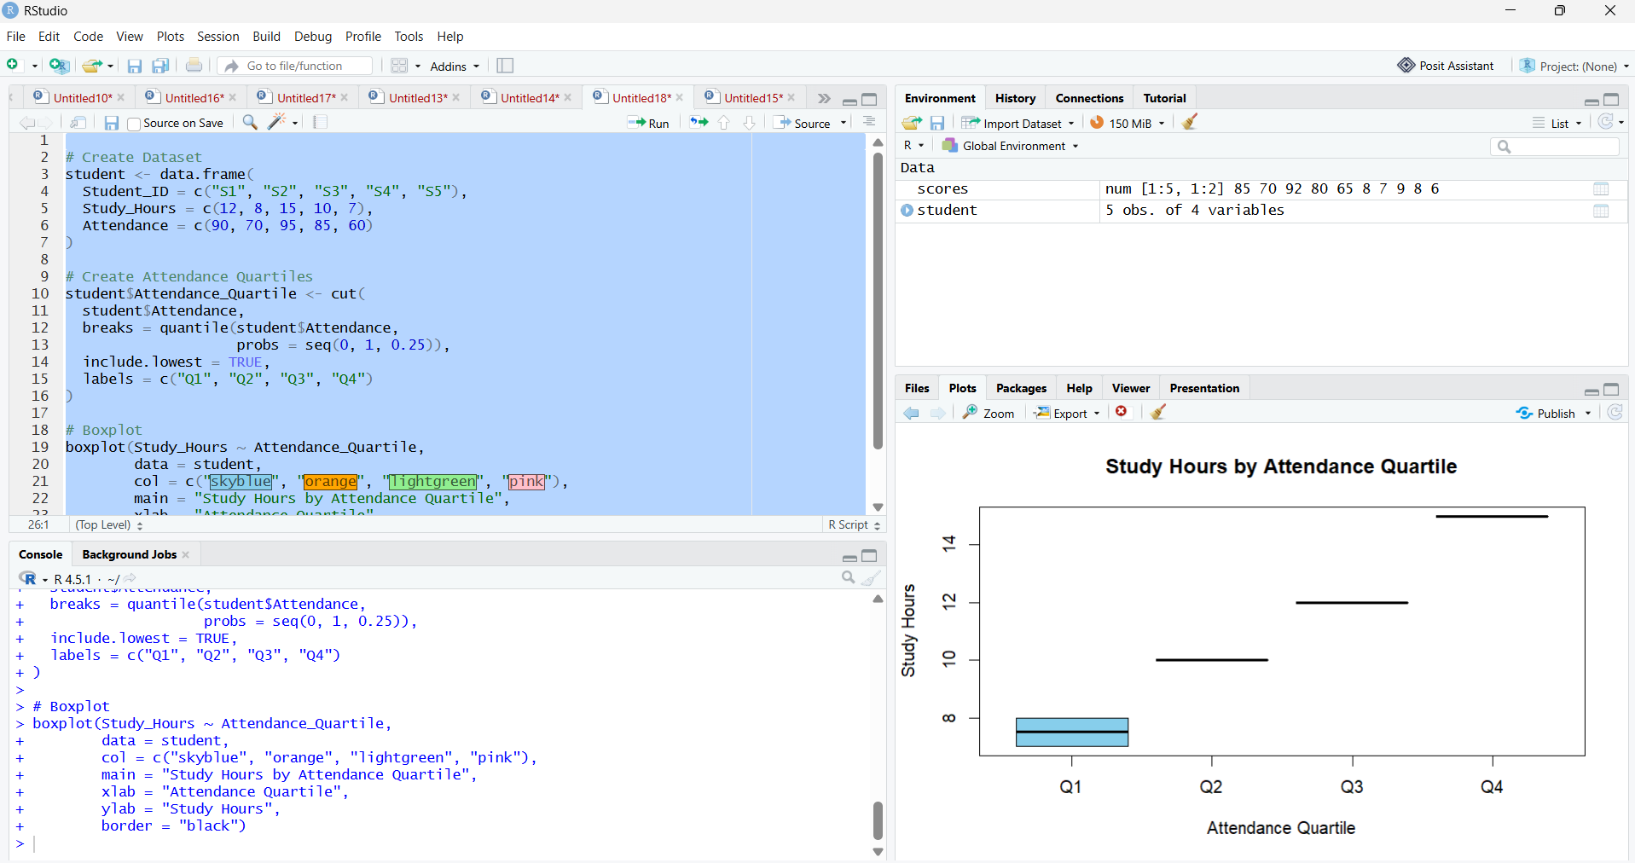

Result
The boxplot is intended to compare study hours across attendance quartiles. However, the dataset contains only five students, and the attendance values produce tied quartile boundaries. Consequently, some groups may contain too few observations or may be empty, making meaningful boxplot comparisons difficult.
Student S3 has the highest attendance (95%) and studies for 15 hours, while S5 has the lowest attendance (60%) and studies for 7 hours. No reliable conclusions about quartile-level medians, interquartile ranges, or outliers can be drawn from such a small dataset.

Question 3: Density Plot of Test Scores

Aim
To construct a density plot of student test scores using R to examine the score distribution, identify its general shape, and assess potential outliers.

Code
Question 3 – Density Plot
# Test Scores
Test_Score <- c(85, 70, 92, 80, 65)

# Density Plot
d <- density(Test_Score)

plot(d,
main = "Density Plot of Student Test Scores",
xlab = "Test Score",
ylab = "Density",
col = "blue",
lwd = 2)

polygon(d,
col = "lightblue",
border = "blue")

rug(Test_Score, col = "red")

# Summary Statistics
print(summary(Test_Score))
print(mean(Test_Score))
print(sd(Test_Score))

Output:
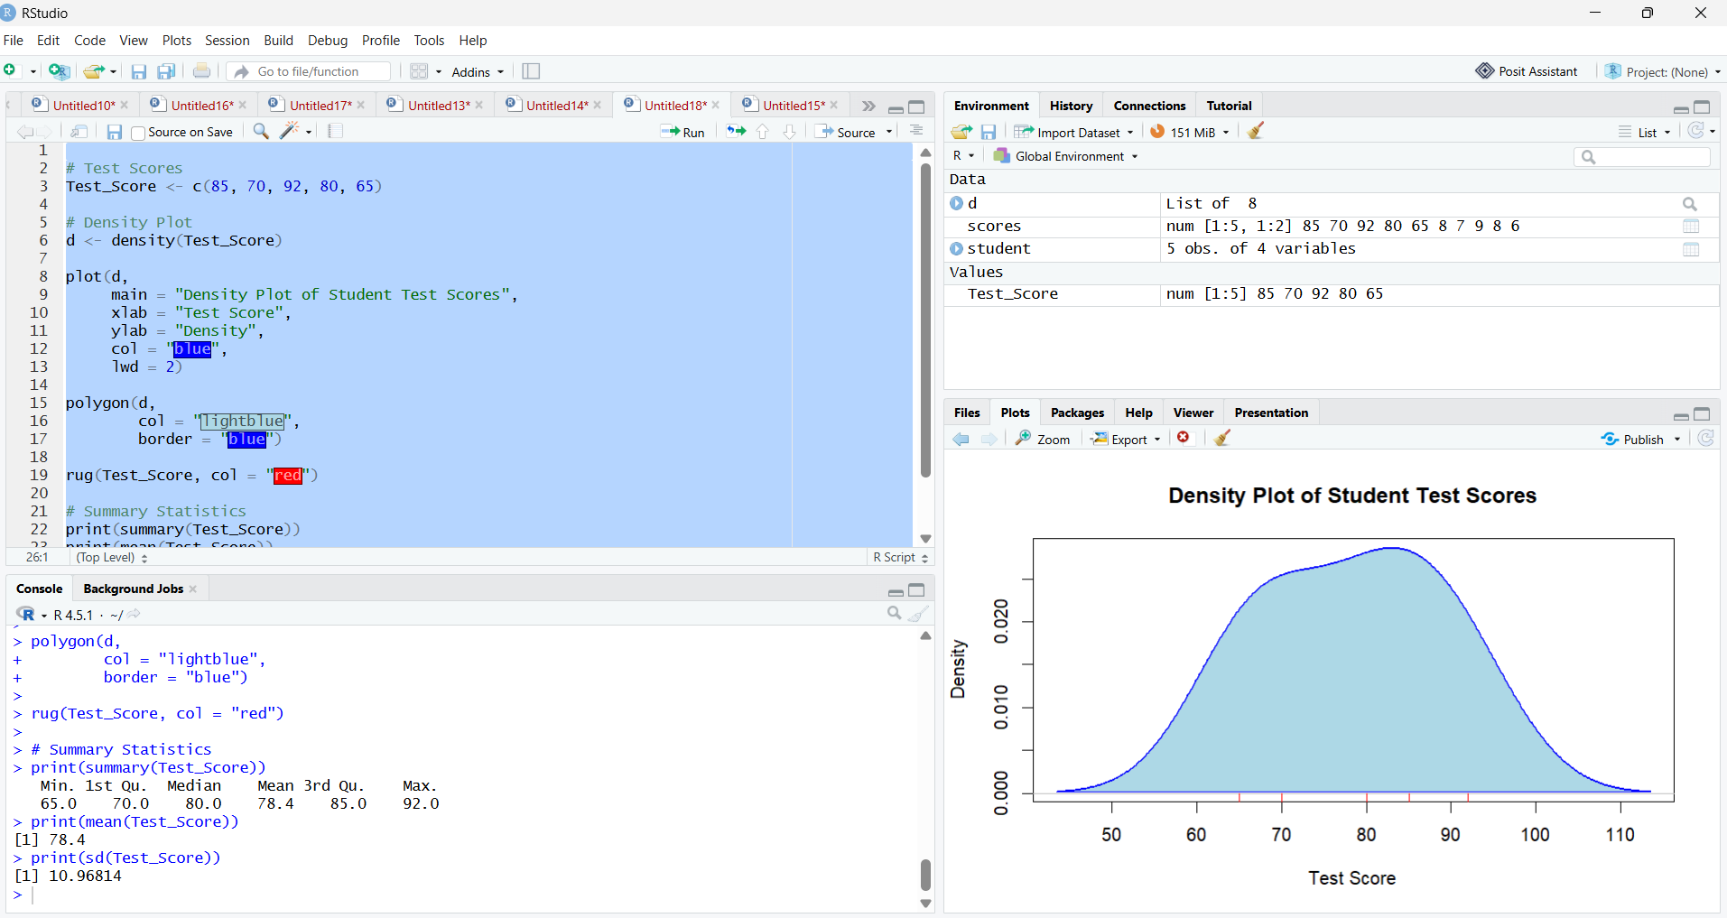

Result
The density plot displays the distribution of test scores ranging from 65 to 92. The mean test score is 78.4, and the median is 80. Student S3 has the highest score of 92, while S5 has the lowest score of 65.
The density curve provides a smoothed representation of the score distribution. However, with only five observations, its shape is sensitive to the smoothing bandwidth. There is insufficient evidence to establish a reliable distribution pattern or identify outliers using the density plot alone.

Question 4: Interactive Scatterplot in Tableau

Aim
To create an interactive Tableau scatterplot with Study Hours on the X-axis, Test Score on the Y-axis, and color representing Participation Score, with an Age filter to explore academic performance patterns.

Output:
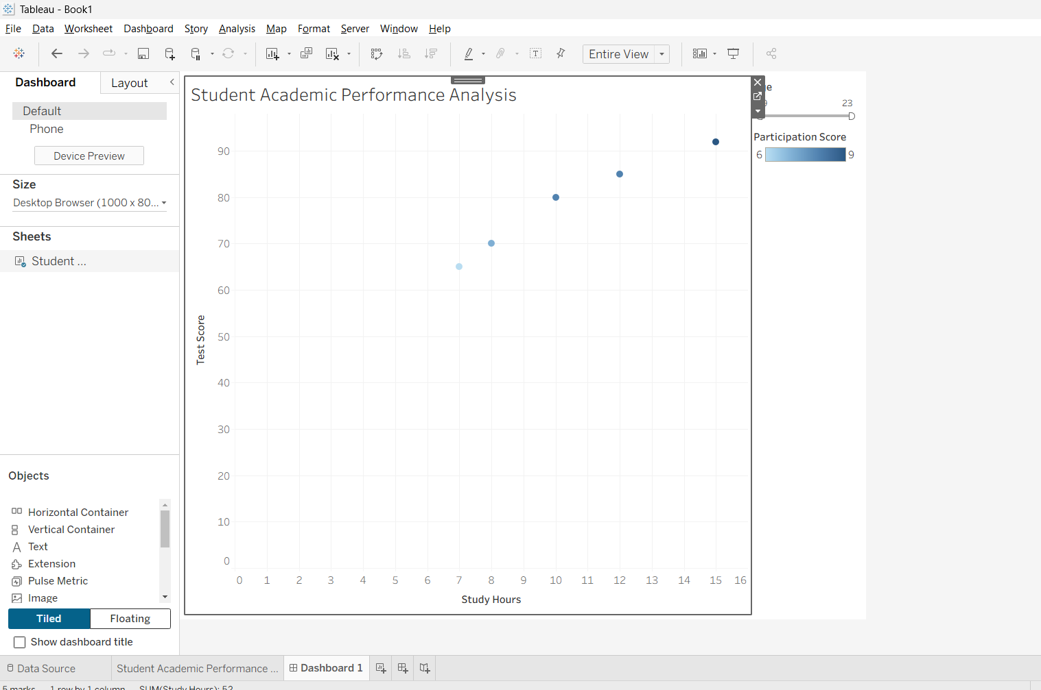

Result
The interactive Tableau scatterplot displays Study Hours on the X-axis and Test Score on the Y-axis, with colors representing Participation Score. The Age filter enables users to explore academic performance among students of different ages.

